FY25 Grant Reports Review – Executive Summary

Allegany Franciscan Ministries analyzed responses from FY25 grant reports (both written and verbal) across six distinct grant program areas: Allegany Community Out Reach (ACOR), Common Good Initiative (CGI), Climate Justice & Care for Creation (CJCC), Nonprofit Capacity & Leadership Initiative (NCLI), St. Clare, and Tau. The analysis reveals meaningful outcomes, shared struggles, and partner-defined pathways to deeper impact.
AT A GLANCE

187  Grant Reports Analyzed |  | 72%  Response Rate to Evaluation Questions |  | 6  Distinct Grant Program Areas |  | 29%  Verbal Reports (Higher Completion)

A Note on Verbal Reporting
Verbal reports are conducted by Allegany program leads via Zoom or phone and comprise 29% of all reports. Verbal reports produced notably more complete responses than written reports. Staff-recorded notes captured richer, more nuanced partner reflections. This finding points to the power of relationship-centered reporting practices.
FOUR CORE THEMES

1 |  | Expanded Services Improving Community Well-Being  Organizations are reaching more vulnerable populations, offering expanded services, and measurably increasing their impact in the communities they serve.

2 |  | Infrastructure, Capacity Building & Leadership Development  Funding is being directed toward critical staff hires, leadership development, technological improvements, staff wellness, and organizational capacity-building.

3 |  | Deepened Community Engagement & Volunteer Growth  Many significant developments center on strengthening community ownership, broadening participation, and expanding volunteer networks.

4 |  | Cross-Sector Collaboration & Broader Systems Impact  Grant partners are increasingly working in partnership with other community-based organizations and across sectors to influence policy and drive systemic change.

Challenges, Support & FY27 Commitments

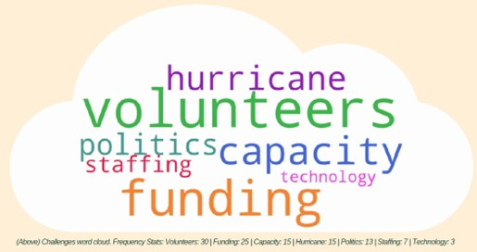
CHALLENGES & LEARNINGS
The primary challenges reported by nonprofit grant partners span organizational capacity and the external environment. Key pressure points include:

Internal Pressures  • Staffing capacity gaps  • Board member recruitment & training  • Volunteer pipeline development  • Technology infrastructure needs  • Funding sustainability |  | External Pressures  • Rising community needs & demand  • Inflation & cost-of-living impacts  • Climate-related disruptions  • Shifting political landscape  • Sector-wide uncertainty

SUPPORT NEEDED BEYOND FUNDING

🤝 Peer Networking  Opportunities to connect with others in their field and aligned funders |  | 📣 Visibility & Storytelling  Support promoting their stories, services, and community events
💚 Wellness Opportunities  Continued wellness programming to address compassion fatigue |  | 🛠 Technical Assistance  Board development, capacity building, and operational support

“Grant partner reflections underscore profound gratitude for Allegany Franciscan Ministries’ trust-based, flexible funding model — which strengthens organizational resilience, adaptability, and confidence in the face of ongoing uncertainty.”

ALLEGANY FRANCISCAN MINISTRIES COMMITS TO THE FOLLOWING IN FY27

1 |  | Peer-to-Peer Learning Cohorts  Facilitate peer cohorts for grant partners to share experiences, gain knowledge, and collaborate on nonprofit management. Topics will include communications/storytelling, fundraising, and leadership development.

2 |  | Monthly Partner Spotlights  Highlight a partner organization monthly on social media to amplify their work and demonstrate Allegany's community impact.

3 |  | Expanded Wellness Offerings  Strengthen virtual and in-person wellness programming for nonprofit organizations and grant partners to address compassion fatigue and burnout across the sector.

Read the full FY25 Grant Report

