Manage Your Requests – New Applicant Dashboard
Written Tutorial
- Once logged in, click the Home icon to access your Dashboard.
There are three columns on your Dashboard.
- Action Needed - Contains your draft requests and any approved requests that still need action. It mirrors the Assigned To You section in left panel.
Color Coding = Yellow
- No Action - Contains requests that do not need further action from the applicant as administrators process the request.
Color Coding = White - for submitted requests waiting on action from Allegany team
Color Coding = Green - an approved request where follow ups are assigned to another member on your team (you can’t take action and can only view since it’s assigned to someone else)

- Historical/Completed - Contains any of your other requests that are no longer active (also known as a closed request); includes Abandoned or Denied requests
Color Coding = Green for past grants awarded that have been closed
Color Coding = Gray for Abandoned or Denied Requests

Completed – if a request was approved but no follow ups are going to be assigned
Color Coding = Green
- 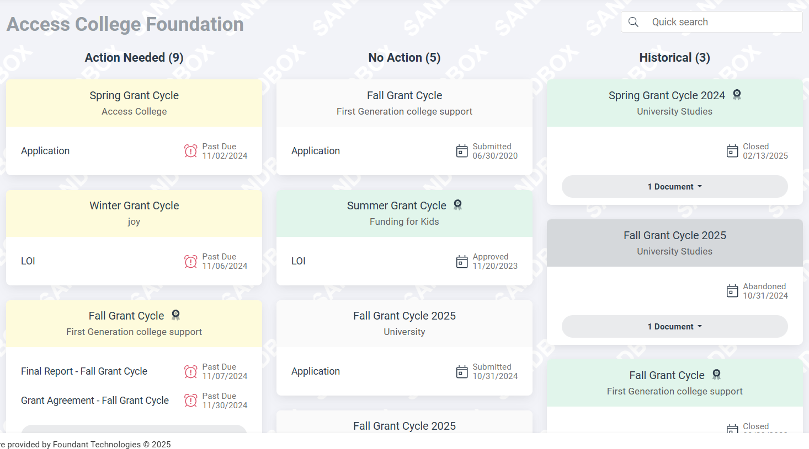
  - The actions you can take on forms for a request depend upon the form's status.
  - Click the document drop-down menu to select and view the forms you have already submitted.
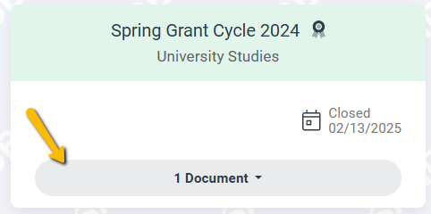
  - Click Start in the To Do panel to start working on a follow up form.
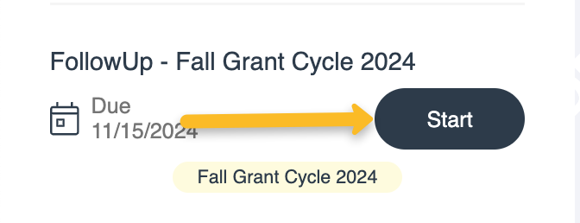
  - Click Continue in the To Do panel to continue working on a form you have not yet submitted.
    - This includes follow up forms which might be assigned if your request is approved. Applicant Tutorial - Submit a Follow Up Form contains details.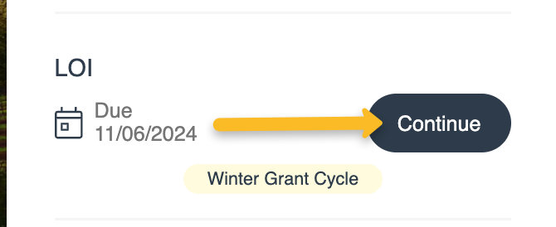
    - For an approved request, click the request header to see the Award Details tab. This displays more information about the grant award.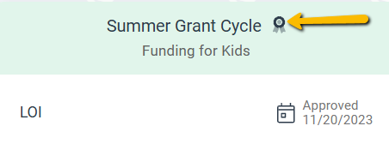
    - The Project Name is listed under the request card header.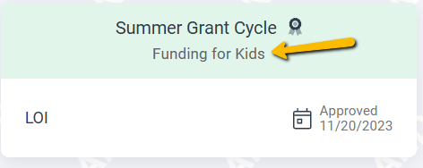
  - The Quick Search can search for a project name within the dashboard.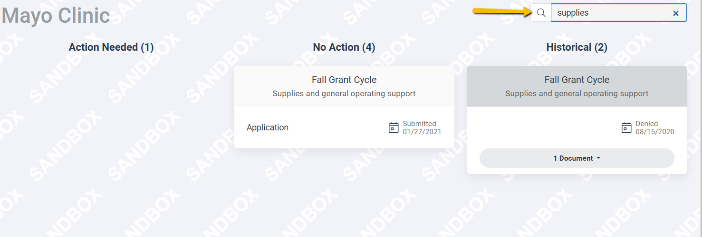
  - Click the menu icon in the upper-right corner of the page to view additional options.
    - Click Edit My Profile to update your contact information or password.
    - Click Sign Out to log out of the site.