New Apply Page
Written Tutorial

- Click Apply to reach the Apply page which lists the available grant opportunities and details about each.
  - If you were provided with an access code, enter it in the upper right-hand corner.
  - Click Preview for any grant opportunity on the page if you would like to view the first form without starting a grant request.
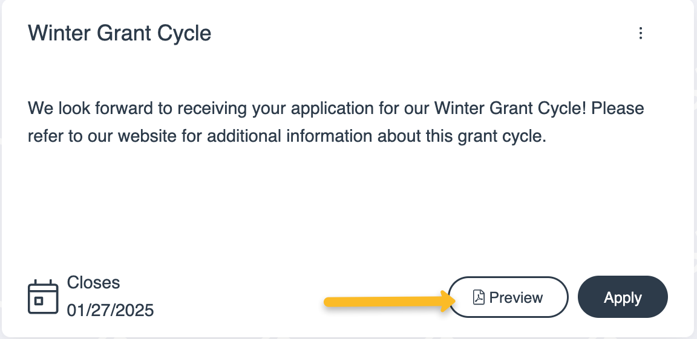
- Click Apply for a grant opportunity when you are ready to start a request.
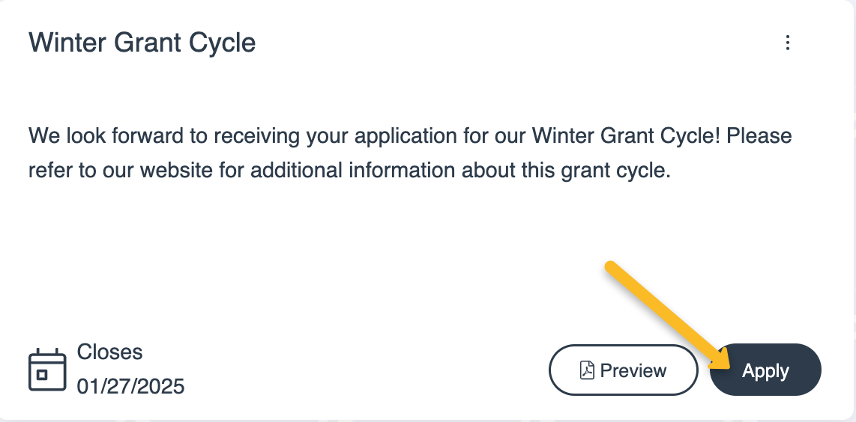
- You will arrive at the first form for the request which is usually an LOI or application.
  - If there is a deadline to submit the form, it is listed at the top of this page.
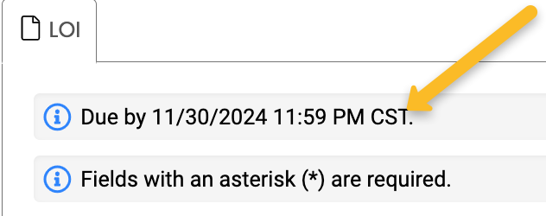
  - Click Question List to download a copy of the form.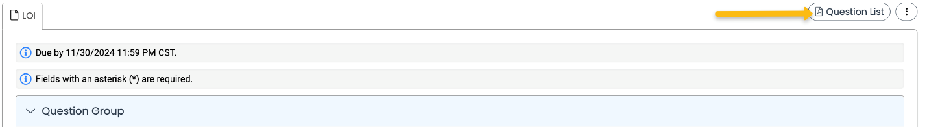
  - Click LOI Packet or Application Packet to download a .pdf copy of the form once you have completed it.
- Complete the questions on the form.
  - Required questions are marked with an asterisk.
  - The system automatically saves your work every 100 characters you type and when you click out of a question. You can click Save at any time.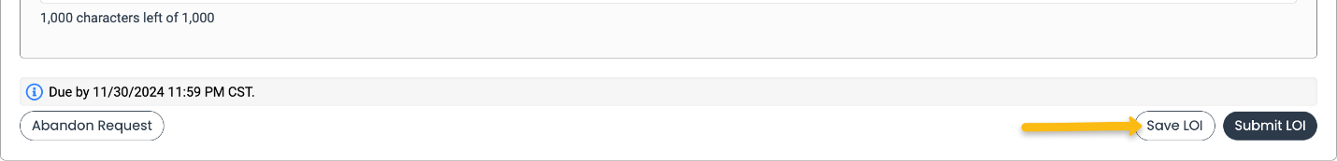
- Click Submit when you are ready to submit the form.
  - If you decide to withdraw your application before submitting it, click Abandon Request instead.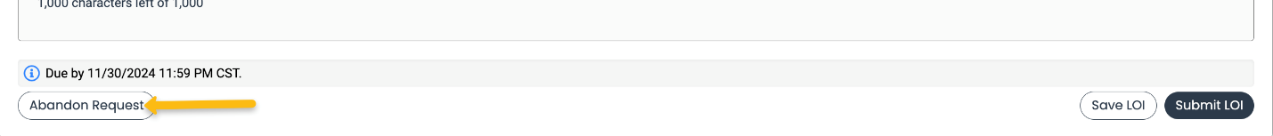
  - The system notifies you of any required questions that were missed. Complete those questions, and then click Submit again on the form.
    - The form cannot be edited once it is submitted.
- You will receive a confirmation message when your form is successfully submitted. Click Continue.